Return to the Text: Literary Criticism and Beyond

James W. Voelz

I. The Problem

Basel, Switzerland, 1984

Hans Frei/“Direction of Fit”

“Use” of Scripture:

1. Revelation of General Truths
2. Revelation of Truths of the Human Mind
3. Reconstruction of Historical Events
4. Reconstruction of the Background and Composition of Biblical Texts

II. The Response: A Literary Approach

Lategan Triptych

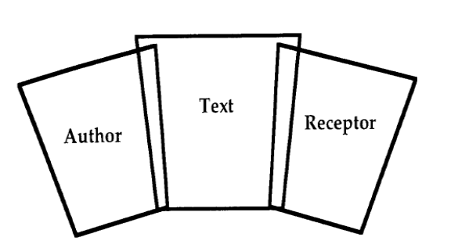

Two Part Response of Literary Criticism

1. The Text as Central Feature of a Written Document
   1. Artistry of the Author
   2. Argumentation of the Text
   3. Depiction of a Narrative
      1. Features of a Story as a Whole
      2. Development of a Story
   4. Question of Historicity
2. The Text as Centerpiece of a Communicative Act
   1. Semantic Dimensions
      1. Rhetoric
      2. Narrative



* 1. Pragmatic Dimensions

Speech-Act Theory

* + 1. Rhetoric
    2. Narrative

III. Moving Forward

Radical Post-Modernism: Right Hand Panel Focus

Oral Performance